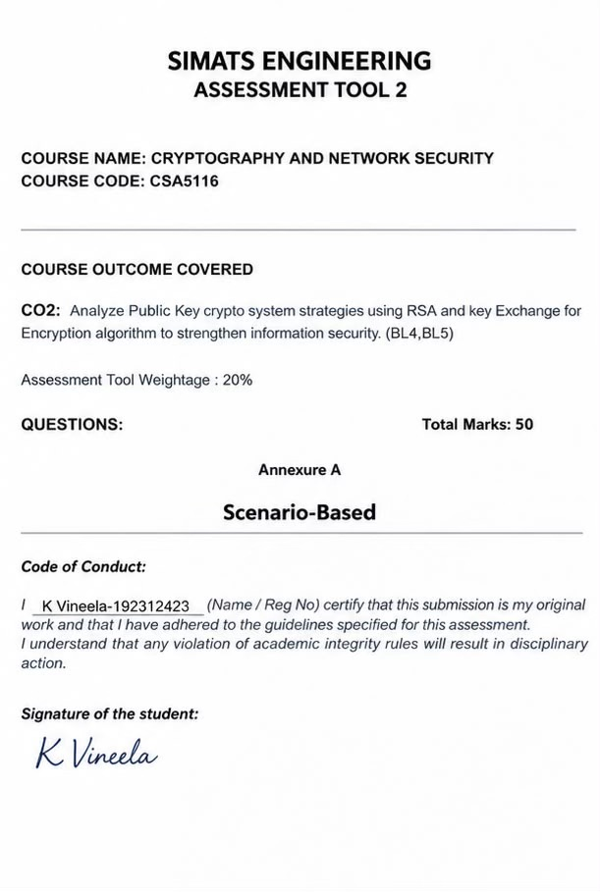
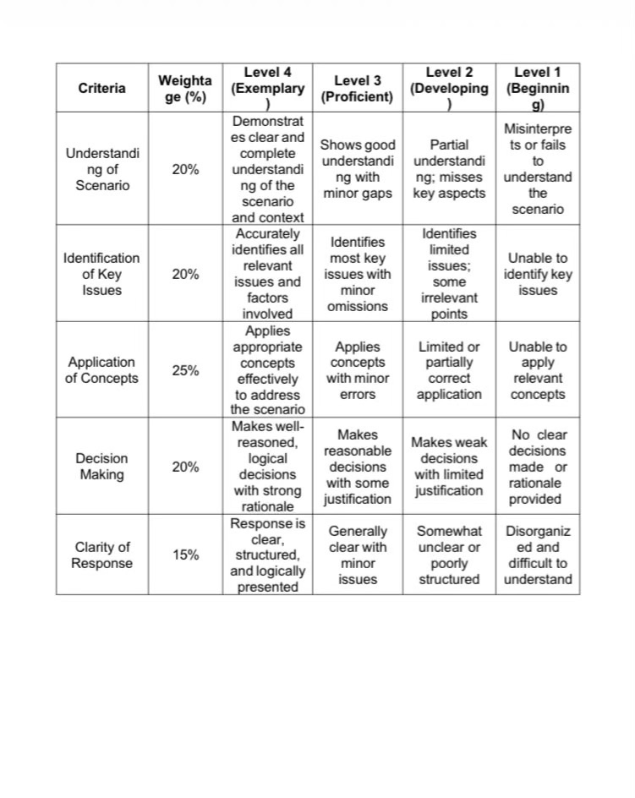
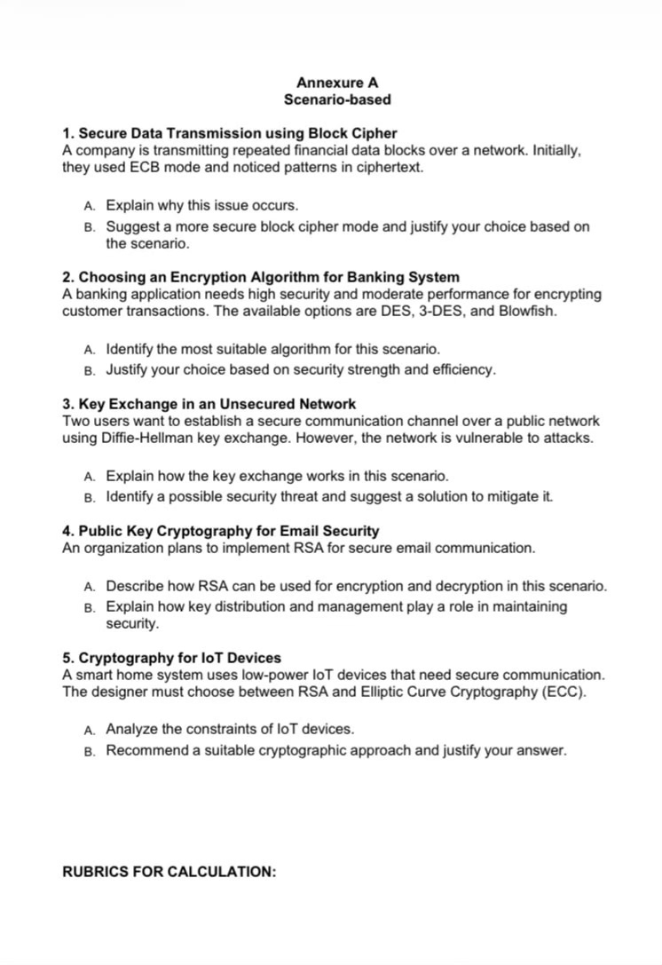
1. Secure Data Transmission Using Block Cipher

1. Introduction
Secure data transmission is an important aspect of network security. Organizations such as banks, financial institutions, and businesses transmit sensitive information over networks every day. This information may include account details, transaction records, payment information, and other confidential data.
Cryptography protects this information by converting readable data, called plaintext, into an unreadable format, called ciphertext. A block cipher is a symmetric encryption technique that encrypts data in fixed-size blocks using a secret key.
However, the security of encrypted data depends not only on the encryption algorithm but also on the mode of operation used. Electronic Codebook (ECB) mode can reveal patterns in encrypted data when repeated plaintext blocks occur. Therefore, selecting a secure block cipher mode is essential for protecting financial information during transmission.
2. Objectives
- To understand the role of block ciphers in secure data transmission.
- To study the working of Electronic Codebook (ECB) mode.
- To identify the security weaknesses of ECB mode.
- To understand how repeated plaintext blocks reveal patterns in ciphertext.
- To recommend a more secure block cipher mode for financial data transmission.
- To explain the importance of confidentiality, integrity, and secure key management.
3. What Is a Block Cipher?
A block cipher is a symmetric-key encryption algorithm that processes data in fixed-size blocks. The same secret key is used for encryption and decryption.
For example, AES (Advanced Encryption Standard) is a widely used block cipher that processes data in blocks of 128 bits.
Main components:
- Plaintext: The original readable information.
- Encryption algorithm: Converts plaintext into ciphertext.
- Secret key: A key used to encrypt and decrypt information.
- Ciphertext: The encrypted, unreadable information.
- Decryption: Converts ciphertext back into plaintext using the correct key.
Working process:
Plaintext → Encryption Algorithm + Secret Key → Ciphertext → Network Transmission → Decryption → Original Plaintext
4. What Is ECB Mode?
ECB stands for Electronic Codebook. It is one of the simplest modes of operation for block ciphers.
In ECB mode, each block of plaintext is encrypted independently using the same secret key.
The encryption process can be represented as:
C₁ = E(K, P₁)
C₂ = E(K, P₂)
Here, P represents a plaintext block, C represents a ciphertext block, E represents the encryption algorithm, and K represents the secret key.
If two plaintext blocks are identical and the same key is used, their ciphertext blocks will also be identical.
Example
Suppose a company transmits financial data containing repeated values:
Plaintext blocks: A | B | A | C
ECB ciphertext blocks: X | Y | X | Z
The first and third plaintext blocks are identical, so they produce identical ciphertext blocks. An observer can identify the repeated pattern even without knowing the secret key.
5. Why Does ECB Reveal Patterns?
ECB reveals patterns because it encrypts every block independently and does not use information from previous blocks.
The main reasons are:
- Independent encryption: Each block is encrypted separately.
- Same key: The same encryption key is applied to every block.
- Deterministic output: Identical plaintext blocks produce identical ciphertext blocks.
- Pattern visibility: An attacker can identify repeated blocks and infer structural information about the original data.
Although the attacker may not immediately discover the actual financial values, visible patterns can provide useful information about the data's structure and repetition.
6. Security Risks of ECB Mode
Using ECB mode to transmit financial data can introduce several risks:
- Pattern leakage: Repeated account fields or transaction values may produce repeated ciphertext blocks.
- Information exposure: Attackers may infer the structure or repetition of sensitive records.
- Weak confidentiality: The encrypted output can reveal information about the plaintext's organization.
- Data manipulation risks: ECB does not provide built-in integrity protection, so ciphertext blocks may be modified, removed, or rearranged without detection by ECB itself.
- Unsuitability for structured data: Financial records often contain repeated fields and predictable formats, making pattern leakage particularly undesirable.
ECB may be useful for limited applications involving independent blocks, but it is generally unsuitable for encrypting multi-block sensitive messages.
7. Recommended Block Cipher Mode: CBC
CBC stands for Cipher Block Chaining. It improves upon ECB by linking the encryption of each block to the previous ciphertext block.
Before encrypting a plaintext block, CBC combines it with the previous ciphertext block using the XOR operation. For the first block, it uses an Initialization Vector (IV).
The encryption process is:
C₁ = E(K, P₁ XOR IV)
C₂ = E(K, P₂ XOR C₁)
C₃ = E(K, P₃ XOR C₂)
How CBC Works
- The original financial data is divided into fixed-size blocks.
- A fresh, unpredictable Initialization Vector is generated.
- The first plaintext block is combined with the IV using XOR.
- The result is encrypted using the secret key.
- Each subsequent plaintext block is combined with the previous ciphertext block before encryption.
- The ciphertext is transmitted to the receiver, who decrypts it using the correct key and IV.
As a result, identical plaintext blocks in different positions generally produce different ciphertext blocks.
Important requirements: CBC requires appropriate padding for incomplete blocks, a securely generated IV, and separate message authentication to detect tampering. CBC alone does not guarantee data integrity.

8. Comparison Between ECB and CBC
Feature | ECB Mode | CBC Mode
Full form | Electronic Codebook | Cipher Block Chaining
Encryption method | Each block is encrypted independently | Each block depends on the previous ciphertext block
Initialization Vector | Not required | Required
Repeated plaintext blocks | Produce identical ciphertext blocks | Generally produce different ciphertext blocks
Pattern leakage | High risk for structured data | Reduces direct pattern leakage
Error propagation | Affects the corresponding block | Can affect the corresponding and following plaintext blocks
Integrity protection | Not provided | Not provided by itself
Suitability for financial messages | Not recommended | Better than ECB when correctly implemented

9. Why Is CBC More Secure for This Scenario?
CBC is more appropriate than ECB for the company's repeated financial data because it reduces the visibility of repeated patterns.
The main advantages are:
- Improved confidentiality: Identical plaintext blocks do not directly produce identical ciphertext blocks at different positions.
- Reduced pattern leakage: The chaining mechanism hides the simple repetition patterns visible in ECB.
- Better protection for structured messages: It is more suitable for multi-block messages containing repeated financial fields.
- Established cryptographic design: CBC is a well-known block cipher mode when implemented correctly.
However, CBC is not automatically secure against every attack. It must be implemented with secure IV generation, authentication, appropriate padding, and correct key management.
10. Modern Alternative: AES-GCM
Although CBC is an improvement over ECB, AES-GCM (Advanced Encryption Standard in Galois/Counter Mode)is generally preferred for new applications.
AES-GCM is an authenticated encryption mode that provides both confidentiality and integrity.
Its advantages include:
- Encrypts sensitive financial information to protect confidentiality.
- Generates an authentication tag that allows the receiver to detect unauthorized modification.
- Does not require block padding.
- Is widely used in modern secure communication protocols.
A unique nonce must be used for every encryption operation with the same key. Reusing a nonce in AES-GCM can seriously compromise security.
For a modern financial communication system, AES-GCM is generally the recommended choice. CBC remains a valid alternative in systems that require it, provided authentication is implemented correctly.
11. Application in Financial Data Transmission
Consider a company sending transaction records between its head office and a remote branch.
The data may contain:
- Account numbers
- Transaction identifiers
- Payment amounts
- Customer reference number
If ECB is used, repeated plaintext blocks may produce repeated ciphertext blocks. An observer monitoring the network could identify patterns in the encrypted records.
If CBC is used correctly, chaining reduces the visibility of repeated patterns. If AES-GCM is used, the company can protect the confidentiality of the records and detect unauthorized changes through authentication.
A secure system should also use protected network connections, reliable key management, access controls, and appropriate monitoring.
12. Best Practices for Secure Data Transmission
The following practices help protect sensitive information:
- Use AES-GCM or another suitable authenticated encryption scheme for new applications.
- Avoid ECB mode for multi-block sensitive messages.
- Generate unique nonces or IVs according to the selected mode's requirements.
- Protect encryption keys using secure key-management procedures.
- Authenticate encrypted messages to detect tampering.
- Use secure communication protocols such as TLS to protect data in transit.
- Validate incoming data and restrict unauthorized access.
- Update cryptographic libraries and follow current security recommendations.
- Avoid implementing encryption algorithms manually; use trusted cryptographic libraries.
- Monitor systems for suspicious activity and investigate possible security incidents.
13. Advantages of Using a Secure Block Cipher Mode
- Protects confidential financial information.
- Reduces the risk of information leakage through repeated patterns.
- Helps secure sensitive communications over networks.
- Supports reliable information exchange between organizations.
- Authenticated encryption can detect unauthorized data modification.
- Improves overall network and information security when combined with appropriate controls.
14. Limitations and Challenges
- Secure encryption requires proper key generation, storage, and distribution.
- ECB does not hide repeated plaintext patterns.
- CBC requires an IV, padding for incomplete blocks, and a separate authentication mechanism.
- AES-GCM requires strict nonce uniqueness for each key.
- Encryption alone cannot prevent all network attacks, endpoint compromises, or unauthorized account access.
- Incorrect implementation can weaken even a strong encryption algorithm.
15. Conclusion
Block cipher modes play an important role in protecting sensitive information during network communication. ECB mode is unsuitable for the company's financial data because identical plaintext blocks produce identical ciphertext blocks, revealing repeated patterns.
CBC provides better confidentiality than ECB by combining each plaintext block with the previous ciphertext block and using an Initialization Vector for the first block. However, CBC must be combined with a secure authentication mechanism to detect tampering.
For new financial communication systems, AES-GCM is generally the better recommendation because it provides both confidentiality and integrity. Selecting an appropriate encryption mode, protecting keys, and following secure implementation practices are essential for reliable data transmission.
16. References
- National Institute of Standards and Technology (NIST), Advanced Encryption Standard (AES), FIPS 197.
- NIST, Recommendation for Block Cipher Modes of Operation: Methods and Techniques, SP 800-38A.
- NIST, Recommendation for Block Cipher Modes of Operation: Galois/Counter Mode (GCM) and GMAC, SP 800-38D.
- William Stallings, Cryptography and Network Security: Principles and Practice.
- OWASP Foundation, Cryptographic Storage Cheat Sheet.
4.Public Key Cryptography for Email Security

1. Introduction
Email is one of the most widely used methods of communication in organizations. Emails may contain confidential information such as business documents, financial reports, passwords, and personal data. If this information is intercepted by unauthorized individuals, it may lead to data leakage and security threats.
Public key cryptography is a security technique that uses two mathematically related keys: a public key and a private key. RSA (Rivest–Shamir–Adleman) is a widely known public key cryptographic algorithm used for encryption, digital signatures, and secure key establishment.
An organization can use RSA-based cryptography to protect email confidentiality, verify the identity of senders, and detect unauthorized changes to messages. However, modern email security systems commonly use hybrid encryption, in which symmetric encryption protects the email content and public key cryptography protects or establishes the symmetric key.
2. Objectives
- To understand the concept of public key cryptography.
- To study the RSA encryption and decryption process.
- To explain the role of public and private keys in email security.
- To understand secure key distribution and key management.
- To explain how digital signatures support sender authentication and message integrity.
- To identify the advantages and limitations of RSA in secure email communication.
3. What Is Public Key Cryptography?
Public key cryptography, also called asymmetric cryptography, uses a pair of keys.
Public key: Shared with other people and used for encryption or signature verification, depending on the operation.
Private key: Kept secret by its owner and used for decryption or digital signing, depending on the operation.
The two keys are mathematically related, but deriving the private key from a properly generated public key should be computationally infeasible when secure parameters are used.
Main components
- Plaintext: The original readable email message.
- Ciphertext: The encrypted, unreadable message.
- Public key: The key distributed to people who need to communicate securely with the recipient.
- Private key: The secret key retained by the recipient.
- Encryption: The process of protecting information.
- Decryption: The process of recovering the original information.
4. How RSA Works
RSA is an asymmetric cryptographic algorithm that uses a public and private key pair.
The main steps in RSA are:
- Key generation: The recipient generates an RSA public key and a corresponding private key.
- Public key distribution: The recipient shares the public key with authorized senders.
- Encryption or key protection: The sender uses the recipient's public key to protect information.
- Transmission: The protected information is sent through the email system.
- Decryption: The recipient uses the corresponding private key to recover the protected information.
RSA must be implemented using secure padding schemes. For encryption, RSA-OAEP is a recommended option where RSA encryption is required.
5. RSA Encryption and Decryption in Email Communication
Consider an organization in which an employee, Alice, needs to send a confidential email to her manager, Bob.
Step 1: Key generation
Bob generates an RSA key pair:
- Public key: Shared with Alice.
- Private key: Stored securely by Bob.
Step 2: Public key sharing
Bob provides Alice with his public key through a trusted method, such as an organizational certificate system.
Alice must verify that the public key genuinely belongs to Bob.
Step 3: Encryption
Alice uses Bob's verified public key to encrypt the information, or more commonly, to encrypt a randomly generated symmetric session key that protects the email content.
The encrypted information is then attached to or transmitted with the email.
Step 4: Email transmission
The encrypted email travels through the organization's mail servers and network. An unauthorized person who intercepts the encrypted content should not be able to recover the original information without the required secret key.
Step 5: Decryption
Bob receives the email and uses his private key to decrypt the protected session key. He then uses that session key to decrypt the email content.
Important: RSA is generally not used to encrypt an entire long email directly. Hybrid encryption is more efficient because symmetric algorithms can encrypt large amounts of data quickly.
6. RSA Encryption and Decryption Formula
RSA is based on modular arithmetic.
The encryption operation is represented as:
C = Mᵉ mod n
The decryption operation is represented as:
M = Cᵈ mod n
Where:
- M = message representative
- C = ciphertext representative
- e = public exponent
- d = private exponent
- n = RSA modulus
In practice, secure RSA encryption uses a padding scheme such as RSA-OAEP rather than applying the basic mathematical formula directly to raw message data.
7. Hybrid Encryption for Secure Email
Hybrid encryption combines asymmetric and symmetric cryptography.
Working process
- The sender generates a random symmetric session key.
- The sender encrypts the email content using a symmetric algorithm such as AES.
- The sender protects the session key using the recipient's verified public key, or uses an appropriate public-key key-establishment mechanism.
- The encrypted email and protected session key are sent to the recipient.
- The recipient uses the corresponding private key to recover the session key.
- The recipient decrypts the email content using the recovered session key.
Advantages
- Efficient encryption of large email messages.
- Secure protection of session keys.
- Reduced computational overhead compared with encrypting all message data using RSA.
- Supports scalable secure communication between users.
8. Role of Key Distribution
Key distribution is the process of securely sharing public keys with the people who need to communicate.
Although public keys do not need to remain secret, their authenticity must be verified. If an attacker substitutes their own public key for Bob's key, Alice may encrypt confidential information for the attacker instead of Bob.
Organizations can distribute and verify public keys using:
- Digital certificates issued by trusted Certificate Authorities (CAs).
- Public Key Infrastructure (PKI).
- Organizational directories containing verified public keys.
- Securely verified key fingerprints.
- Managed enterprise email security systems.
Key distribution helps ensure that the sender encrypts information for the intended recipient and verifies the identity associated with a public key.
9. Role of Key Management
Key management includes the generation, storage, use, renewal, backup, revocation, and destruction of cryptographic keys.
Important key management practices
1. Secure key generation: Generate RSA keys using trusted cryptographic software and secure random number generators.
2. Private key protection: Store private keys in protected devices, encrypted key stores, or hardware security modules where appropriate.
3. Access control: Restrict private key access to authorized users and processes.
4. Key backup and recovery: Establish secure backup and recovery procedures when organizational requirements permit. Backup copies must receive the same protection as the original keys.
5. Key rotation: Replace keys according to the organization's security policy and when compromise is suspected.
6. Certificate validation: Verify certificate validity, identity, trust chain, and revocation status where applicable.
7. Key revocation: Revoke compromised or no-longer-trusted certificates and keys through the relevant organizational procedures.
8. Secure key destruction: Remove obsolete keys securely when they are no longer needed, while considering whether old encrypted emails must remain accessible.
Effective key management prevents unauthorized decryption, impersonation, and misuse of cryptographic identities.
10. Digital Signatures in Email Security
RSA can also be used for digital signatures, which provide a different security function from encryption.
When Alice digitally signs an email:
- Alice creates a digital signature using her private signing key and a secure signature scheme.
- Bob verifies the signature using Alice's public key.
- Successful verification provides evidence that the message was signed using the corresponding private key and that the signed content has not been altered.
Digital signatures support:
- Authentication: Helps verify the sender's identity when the signing key is reliably associated with that person.
- Integrity: Detects changes to the signed message.
- Accountability: Provides evidence of signing, although it does not automatically guarantee legal non-repudiation in every situation.
For RSA signatures, modern implementations should use a secure scheme such as RSA-PSS where supported. Email protocols and applications may use other standardized signature formats.
Note: Encryption and digital signatures serve different purposes. Encryption protects confidentiality, while digital signatures support authenticity and integrity. Secure email may use both.
11. Security Threats and Preventive Measures
Security threat | Preventive measure
Public key substitution | Verify certificates and public key fingerprints
Private key theft | Use secure storage, access controls, and hardware protection
Weak RSA keys | Use suitable key sizes and trusted cryptographic libraries
Email interception | Encrypt message content using a secure hybrid encryption system
Message modification | Use digital signatures or authenticated encryption
Expired or compromised keys | Monitor certificate status and revoke compromised credentials
Loss of private keys | Maintain appropriately protected recovery procedures
Phishing and impersonation | Verify sender identity and use organizational security controls

12. Advantages of RSA in Email Security
- Supports secure distribution of cryptographic secrets.
- Helps protect confidential email content through encryption or hybrid encryption.
- Supports digital signatures for sender authentication and message integrity.
- Reduces the need for communicating a shared secret key in advance.
- Integrates with certificates and Public Key Infrastructure.
- Supports secure communication across organizational networks.
13. Limitations of RSA
- RSA is computationally more expensive than symmetric encryption for large amounts of data.
- Public keys must be authenticated to prevent substitution attacks.
- Private key compromise can expose protected information, depending on the key-establishment method and system design.
- Incorrect padding or poor implementation can introduce serious vulnerabilities.
- Lost private keys may make encrypted messages unrecoverable.
- RSA does not automatically protect message metadata, such as the sender, recipient, subject, or transmission timing.
- RSA alone does not guarantee protection against phishing, malware, or compromised email accounts.
14. Applications of RSA-Based Email Security
RSA-based cryptography can support secure communication in:
- Banks and financial institutions.
- Government departments.
- Corporate offices.
- Healthcare organizations.
- Legal and consulting firms.
- Educational institutions.
- Organizations exchanging confidential documents.
15. Best Practices for Implementation
- Use trusted, well-maintained cryptographic libraries.
- Use hybrid encryption rather than encrypting large emails directly with RSA.
- Use suitable RSA key sizes, commonly 2048 bits or stronger according to the organization's security requirements.
- Use RSA-OAEP for RSA encryption and RSA-PSS for RSA signatures where appropriate.
- Verify recipient public keys before encrypting confidential information.
- Protect private keys with strong access controls and secure storage.
- Use digital signatures when sender authentication and message integrity are required.
- Follow established secure email standards and organizational policies.
- Plan for certificate renewal, key revocation, and key recovery.
- Consider modern alternatives where appropriate, including standardized elliptic-curve cryptography and hybrid post-quantum approaches.
16. Conclusion
Public key cryptography plays an important role in securing email communication. RSA provides a mechanism for protecting information using a recipient's public key and recovering it using the corresponding private key. It can also support digital signatures that help verify the sender and detect message modification.
However, successful email security depends on more than the RSA algorithm. Public key distribution must establish authenticity, private keys must be protected, and key management procedures must address renewal, backup, and revocation.
For practical email systems, hybrid encryption is generally preferred because it combines efficient symmetric encryption for message content with public-key cryptography for session-key protection. When combined with digital signatures, certificate validation, and secure key management, it provides a stronger foundation for confidential and trustworthy email communication.
17. References
- Rivest, R. L., Shamir, A., and Adleman, L. — A Method for Obtaining Digital Signatures and Public-Key Cryptosystems, Communications of the ACM, 1978.
- National Institute of Standards and Technology (NIST) — Digital Signature Standard (DSS), FIPS 186-5.
- NIST — Recommendation for Pair-Wise Key-Establishment Schemes Using Discrete Logarithm Cryptography, SP 800-56A.
- NIST — Recommendation for Key Management: Part 1 – General, SP 800-57 Part 1.
- Internet Engineering Task Force (IETF) — Public-Key Cryptography Standards (PKCS) #1: RSA Cryptography Specifications Version 2.2, RFC 8017.
- Internet Engineering Task Force (IETF) — S/MIME 4.0 Message Specification, RFC 8551.

